* **Typeof** tell the data type.
* Promot(‘enter your name’) is pop which want inpute from the user and
* Alert(‘hello’) its just pop the message.
* If we clear the console in the inspect then it will clear the code not the value stored in the browser. if we want to clear that also click the reaload with right click and go remove chase and hars reload
* Variable convetion conatian the number, alphabate,_,$ this only contaion
* Varname.length show the length of the string.
* 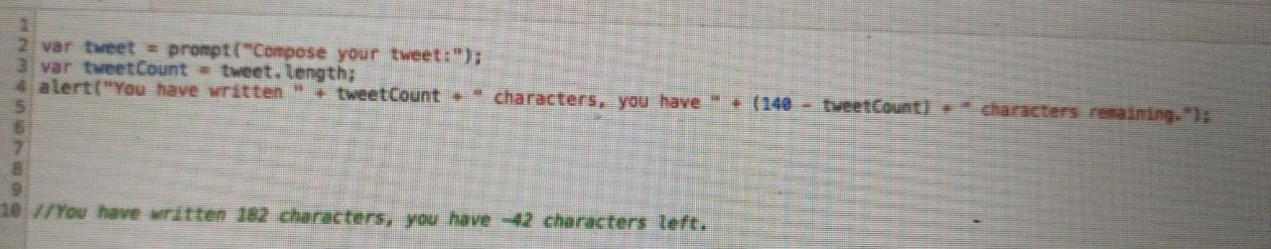
* This above code is showing when you written in any specific length of message then it shows how much you write and how much you left. And also use to show the only given to the length like if you write the 200 line mgs but you have to allowed to 140 then it will only show till the 140 not abouve to it and just show how much will be remaining.
* toUppercase() and to lowercase() is showing the upper and lower case of all words.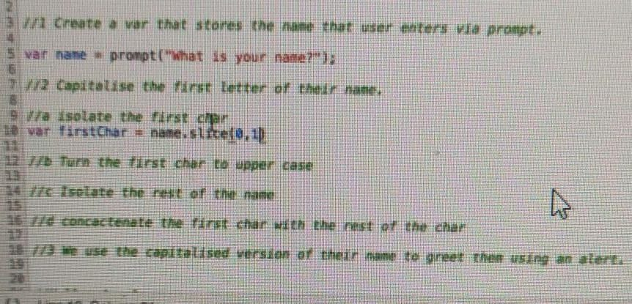
* 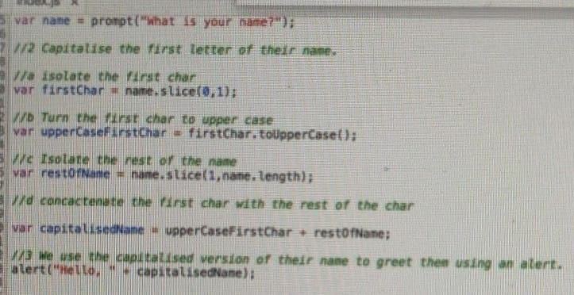
* Anilesh mathur read in the class seven =Anilesh Mathur Read In The Class Seven.
* 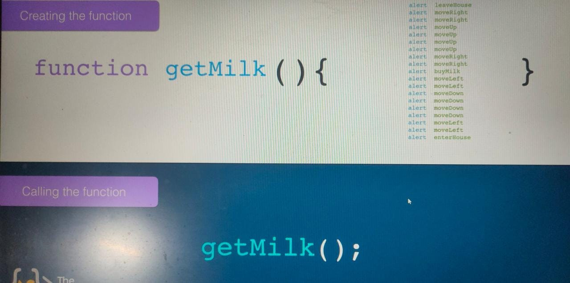
* To create the random no use Math.Rrandom(); 16 place decimal digit its between 0-0.9999999999999999(16times 9)

Random No.Genrator:

var a =Math.random();

var a=a*6;

var a=Math.floor(a)+1;

console.log("the random no. is coming to "+a);

Love calculator:

var name1=prompt("enter the your name");

var name2=prompt("enter the name of your lover");

var a =Math.random();

var a=a*100;

var a=Math.floor(a)+1;

console.log("Love calculato is showing that "+name1 +" and " +name2 +" love each othe with "+ a + "% of love on the scale of 100");

alert("Love calculato is showing that "+name1 +" and " +name2 +" love each othe with "+ a + "% of love on the scale of 100");

**fizz,buzz,fizz-buzz:**

var output = [];

var count =1;

function fizzbuzz(){

while(count<=100){

if(count%3===0 && count%5===0){

output.push("fizz-buzz");

}

else if(count%5===0){

output.push("buzz");

}

else if(count%3===0){

output.push("fizz");

}

else{

output.push(count);

}

count++;

}

console.log(output);

}

fizzbuzz();

**DOM:-**

When we loadup the page the html convert into the DOM in which all elemnt convert into

the object.

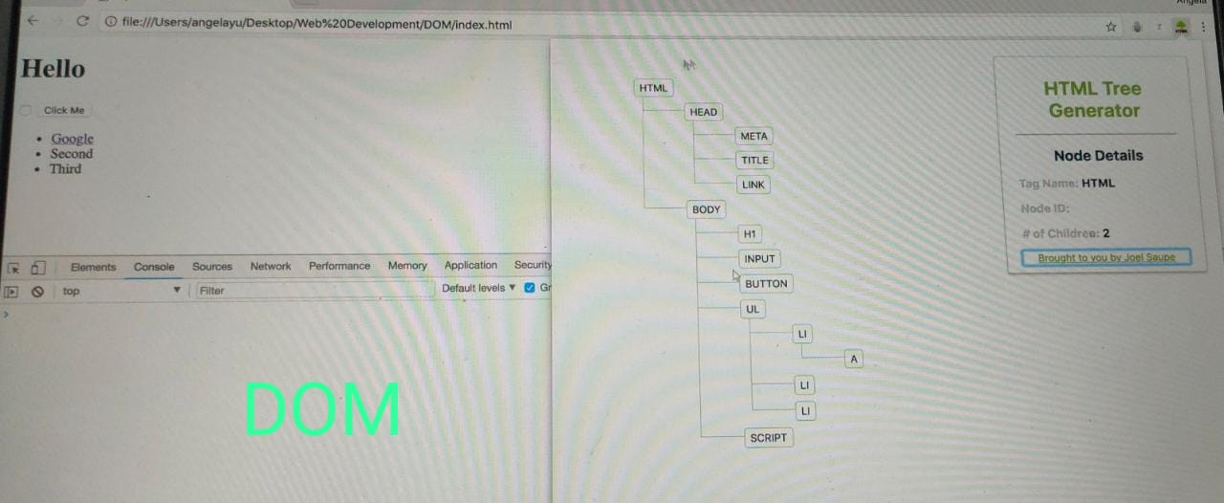

Every object have the property and method property tell about the object and method tell about that what can object do .

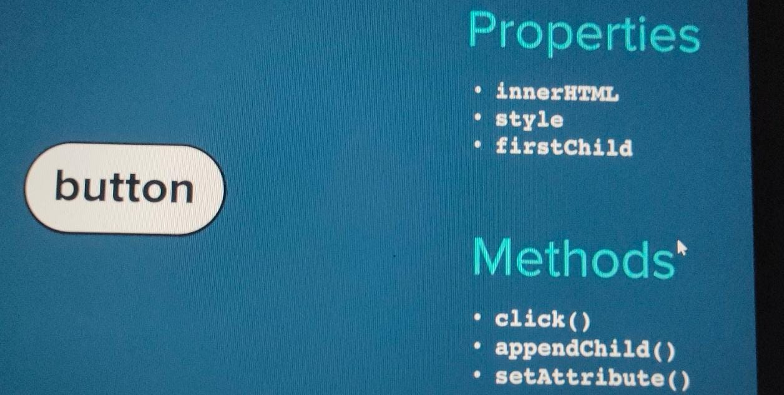

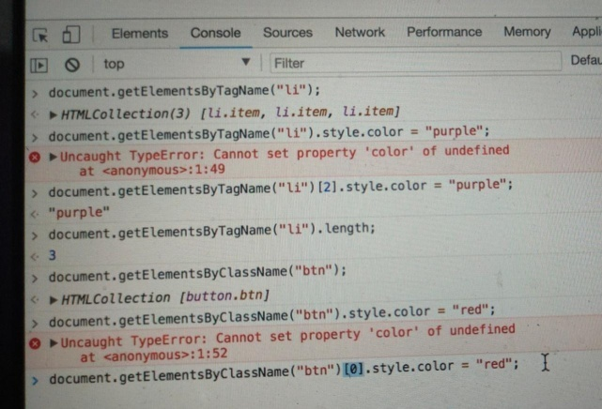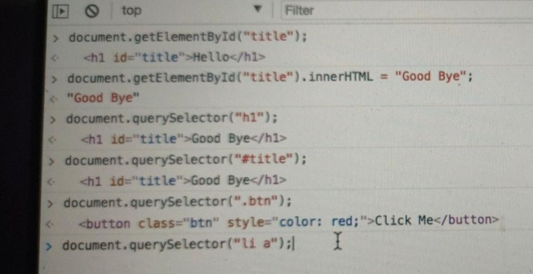

If we combined the selector then the without space then that is in the same elemnt or if not then it is in different elemnt. If there is a li with the classname item then we say that li.item.

Space for two selecter it means it is in herarci

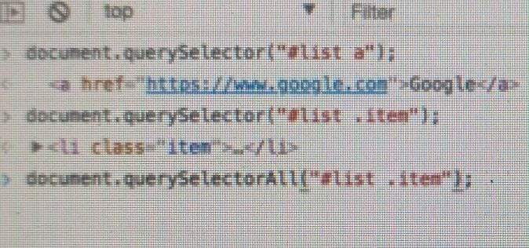

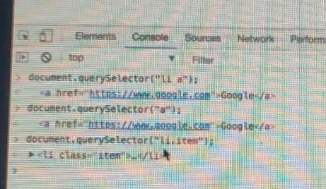

By queryselcator change stuly the caonvantion of property change is used the camel case.

If we use the style in css then why we use it in the javascript bocs we can change the css by the daynamic like toggle the button when button show when it hide.

Document.querySelector(“button”).classList.add(“invisible”);

Invisible class css is right under the css file but visible through the javascript command

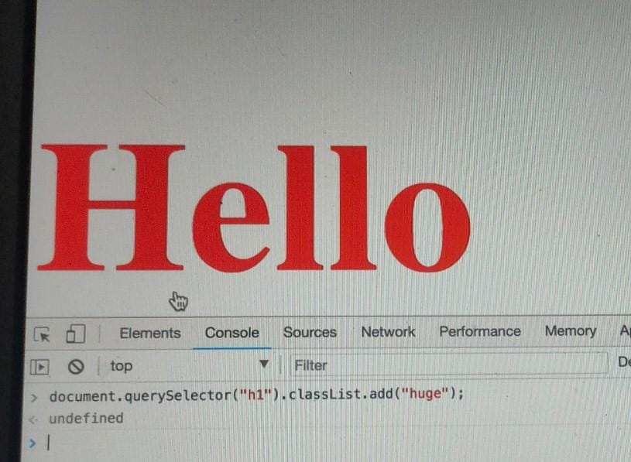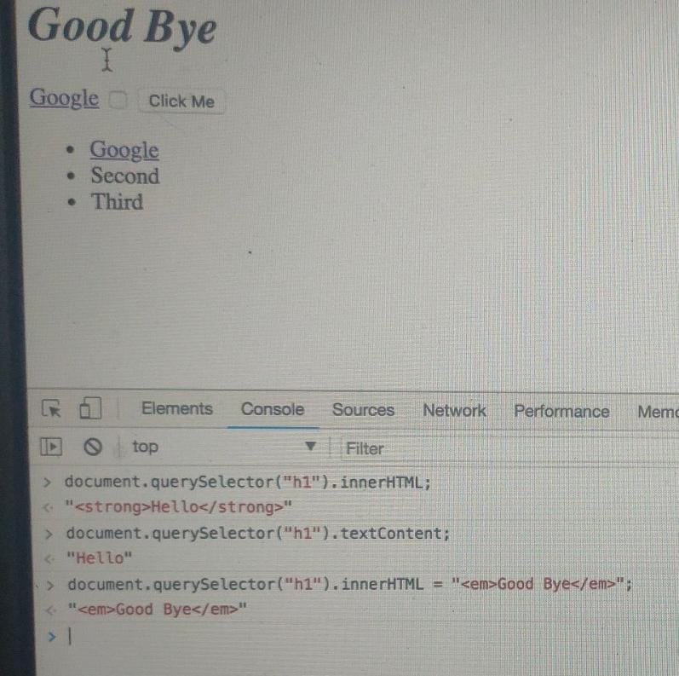

There is difference between in the ineerhtml and textContent in innerhemlt write everything under that tag and it will be write as a string in the double quote.

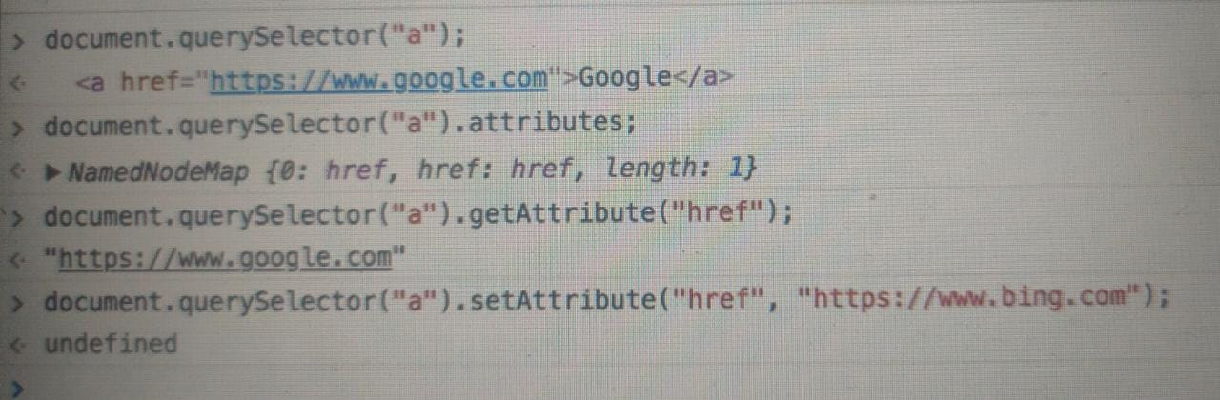

We can get anad set the attribute by the use of .getAttribute and Set.Attribute

If in the event listener we write the functionname it will run after the event done or if we use

the functionname() then it is call just run before the code and also when the event is done.

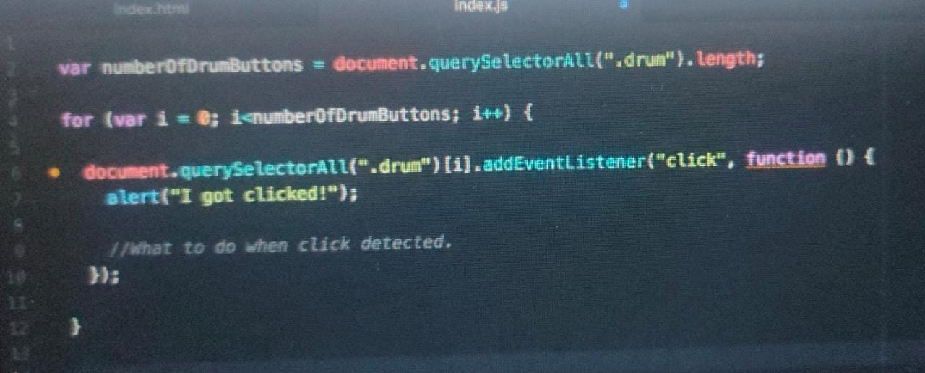

Higher order function are function that can take other functions as a input.

This not avilabe in all the laungauge but present in the javascript

Debugger is use to see the every setup taken by the browser. Which help us in the debugging.

1. function add(num1, num2) {
2. return num1 + num2;
3. }
5. function subtract(num1, num2) {
6. return num1 - num2;
7. }
9. function multiply(num1, num2) {
10. return num1 * num2;
11. }
13. function divide(num1, num2) {
14. return num1 / num2;
15. }
17. function calculator(num1, num2, operator) {
18. return operator(num1, num2);
19. }

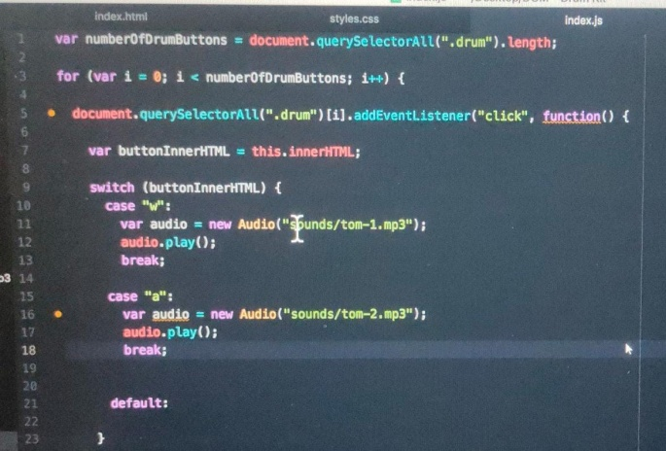

If not any case will be found that is run thedefault code other wise choose a/c to them .

In the higher order function the other function as a inpute and the function as inpute will be called the callback and which object explrence the event by that object this call back is called.

How the callback works

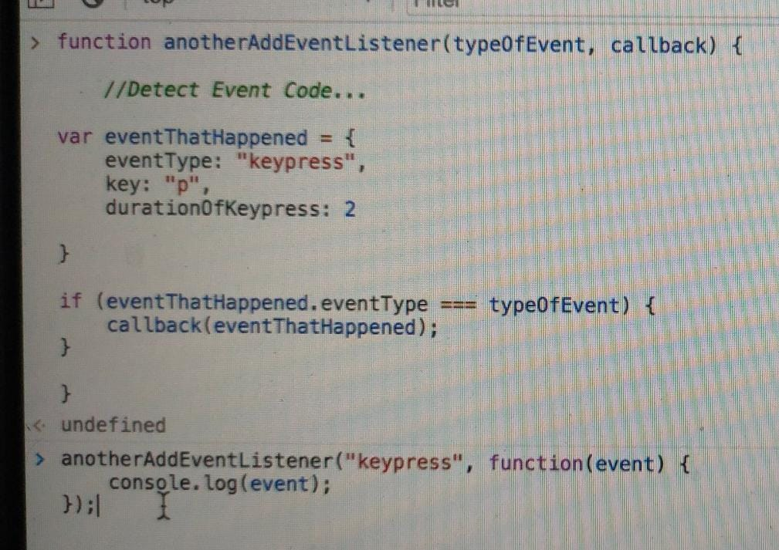

**NPM is a package manager used to install, delete, and update Javascript packages on your machine.** NPX is a package executer, and it is used to execute javascript packages directly, without installing them.

JQuery:-

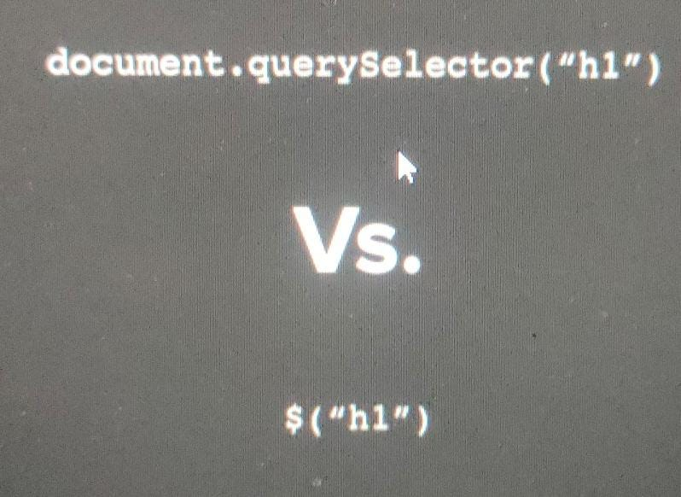

In the jQuery we can write the Jquery() and also the $() both are same

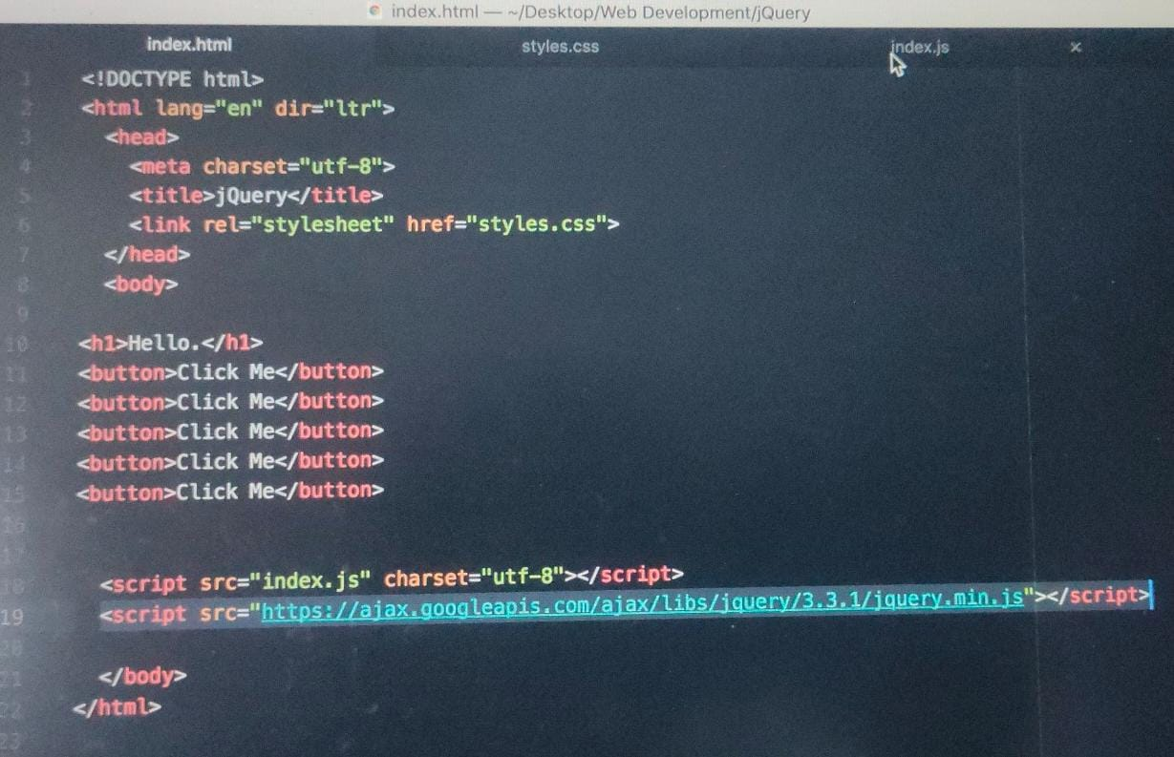

The think is must be that we have to put the line 19 above the 18 other vies it showing error of the missing jquery.

We don’t need to write the line 19 in the header if we writ ethen we have to need to write the in js file $(document).ready(function(){

Then write the js code }

Bocs if we write the 19 line in header it is partial ready si we need to use the .ready before excute the code of the js .

How minification work reduce the file size:-

Why we minify the js and css code bocs their size is reduce and is to load and handle.

Its just a simply think is that it is remove unwanted space and everthing bocs it know what is use and how so no need of space.

Selecting element with Jquery:-

Their no difference between seleceting one and all bocs we just use the $(“button”);

If we write the $(“h1”).css(“font-size”) it will give the value of the of the font-size

If we write the $(“h1”).css(“font-size”,”5rem”)this will set the property.

Hasclass give Boolean it is present or not.

**Text manipulation:-**the $(“h1”).text(“bye”) now its change hi to bye

text innerhtml and html work same.

**Attribute manipulation;-** $(“img”).attr(“src”); it give the source of the img.

$(‘img’).(“class”) this will give the all class associated to the img.

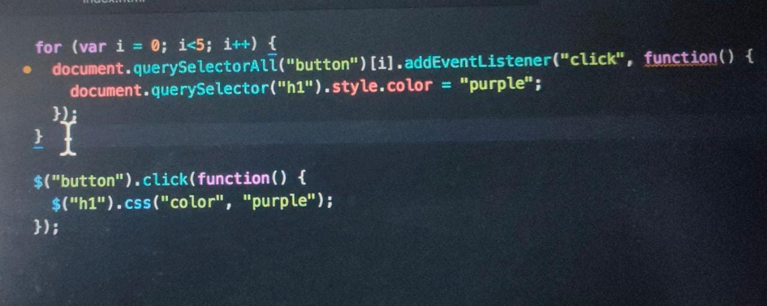

The differencd of using jquery not need of the for loop .

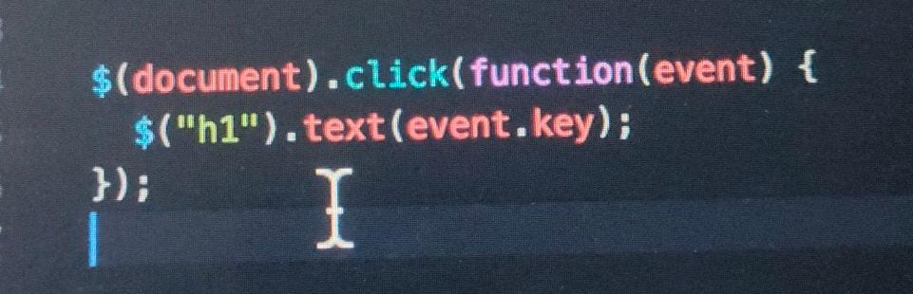

This is usew to show the change.

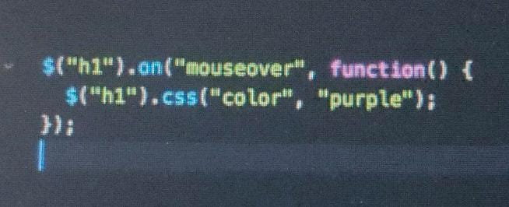

Also wirte like this the event then the call back function.